**Exploratory test session Inbound Shipments for Open m-Supply Web System**

An user creates an inbound shipment by manually creating a new inbound shipment to a new Supplier, adding 1 Item.

An user creates an inbound shipment by manually creating a new inbound shipment to a new Supplier, adding items as a Batch.

An user modifies an inbound shipment before delivery, by adding new items as a master List.

Multiple users adding items to the inbound shipment by manually.

Multiple users modifying inbound shipment before delivery, by deleting and adding new items.

User changes the status of new inbound shipment from new to delivered.

User changes the status of delivered orders to received status.

User changes the status of received orders to Verified status.

User changes the status of orders to on hold.

User should not able to deleting the order once they have delivered, received, verified.

**Executive summary**

**Successes**

Created 4 inbound manual shipments for the Store1, and deleted 1 order before delivering. Additionally, user modified the orders by adding, deleting new items.

**Questions**

Should the user can create an inbound orders for past dates (order date < current date) with special approval from the super user? There may be incidents, i.e. An user will order the shipment offline and update the system in next date.

**Warnings, Ideas or Suggestions Problems**

**Date filter problems**: Date Calander not getting enabled to current date, once user executed the filter option. As shown in the below screenshot, I have used date filter option to select past order (11th August), after that I have clicked the Calander to select a different date, and noticed that the dates are disabled from 12th August to Today (24th August).

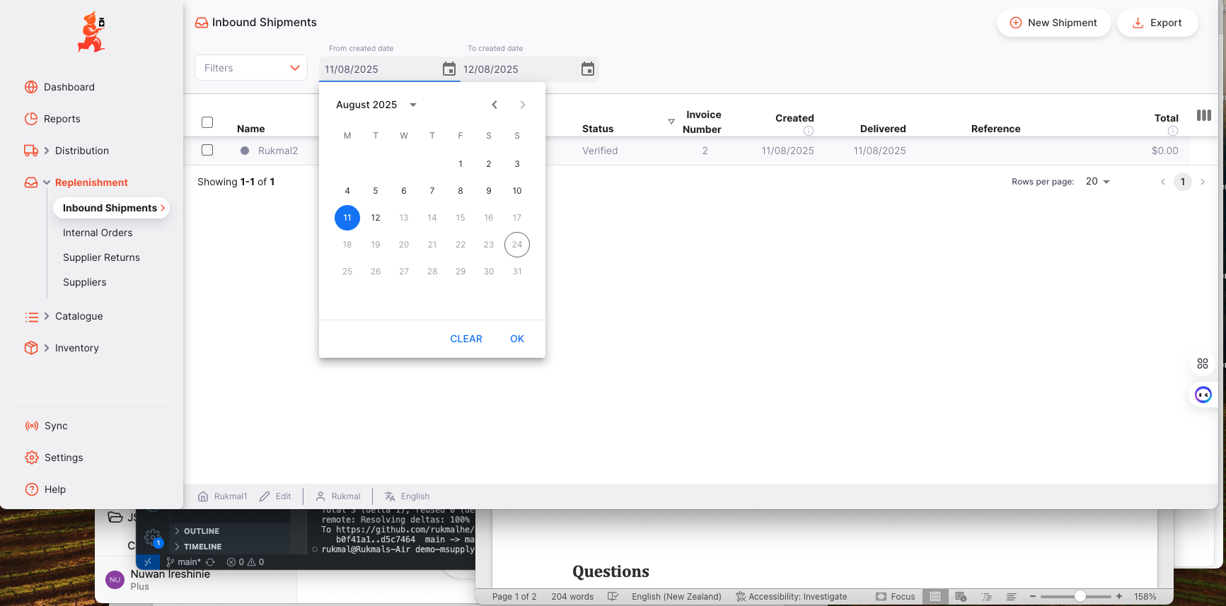

**Audit Log Details are less:** There is no audit log to check complete inbound history for users, i.e. When the user returns the order, the shipment disappeared from the inbound shipment screen and appears in the Supplier Return screen, but the user cannot see actual order history/audit log in an single screen.

As shown in the below screen, the log is not providing complete details/past history. It should be more detail, when the order is created, and the reasons for returning ete.

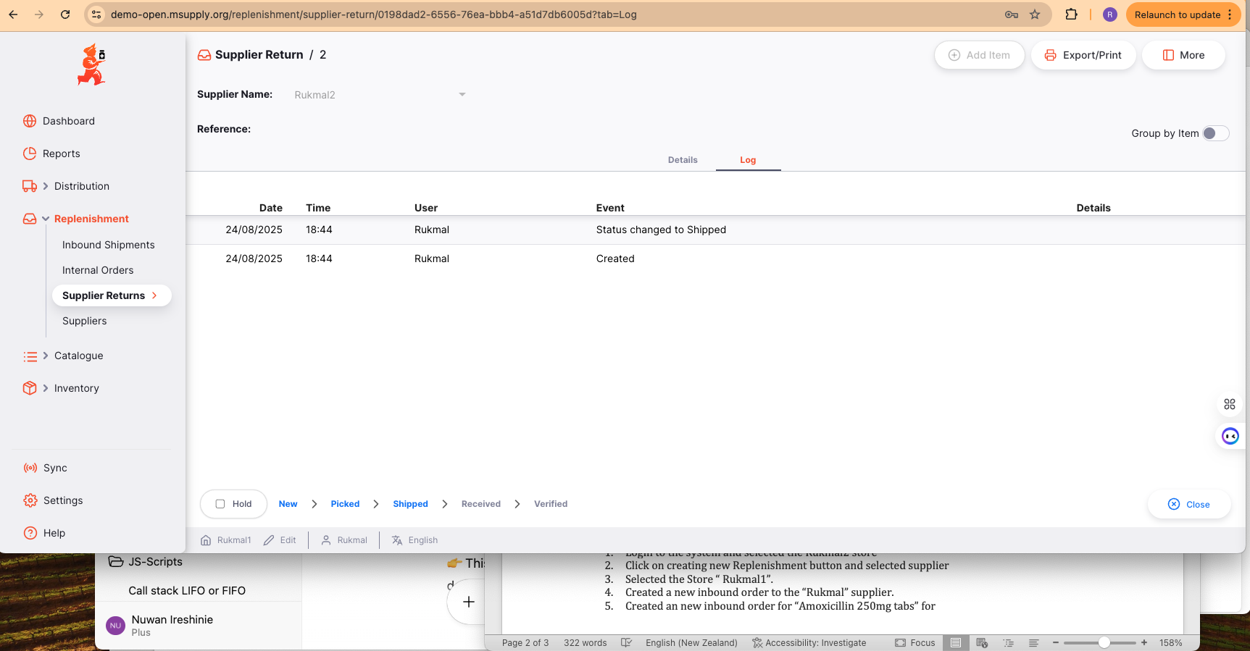

**Flow is not clean for deleting items:** Users are able to delete items even after the items are delivered, received. There is an warning displayed “After delivering, the zero qty items will be removed from the list. The idea is to freeze the inbound items when delivering.

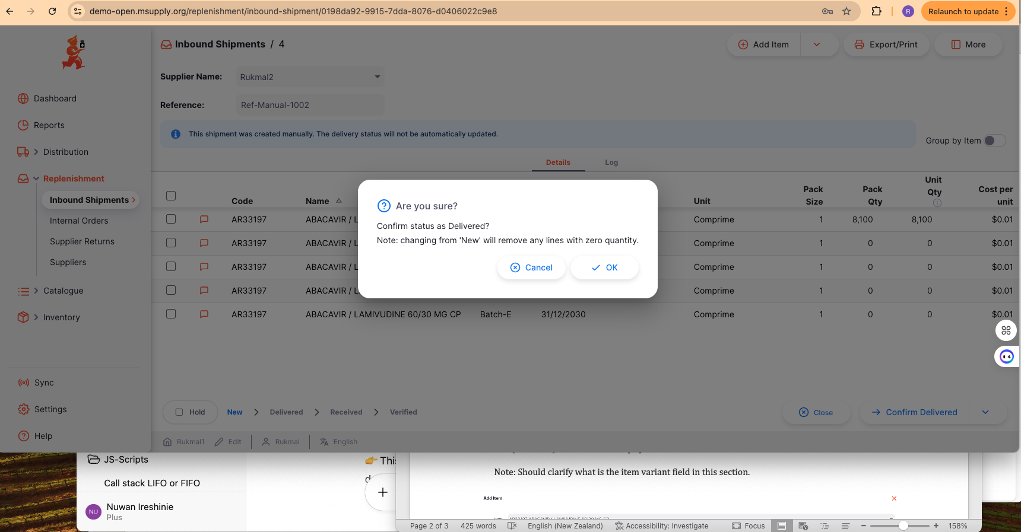

All the items for the inbound shipment were removed by deleting, and the logs doesn’t display the details of the activities.

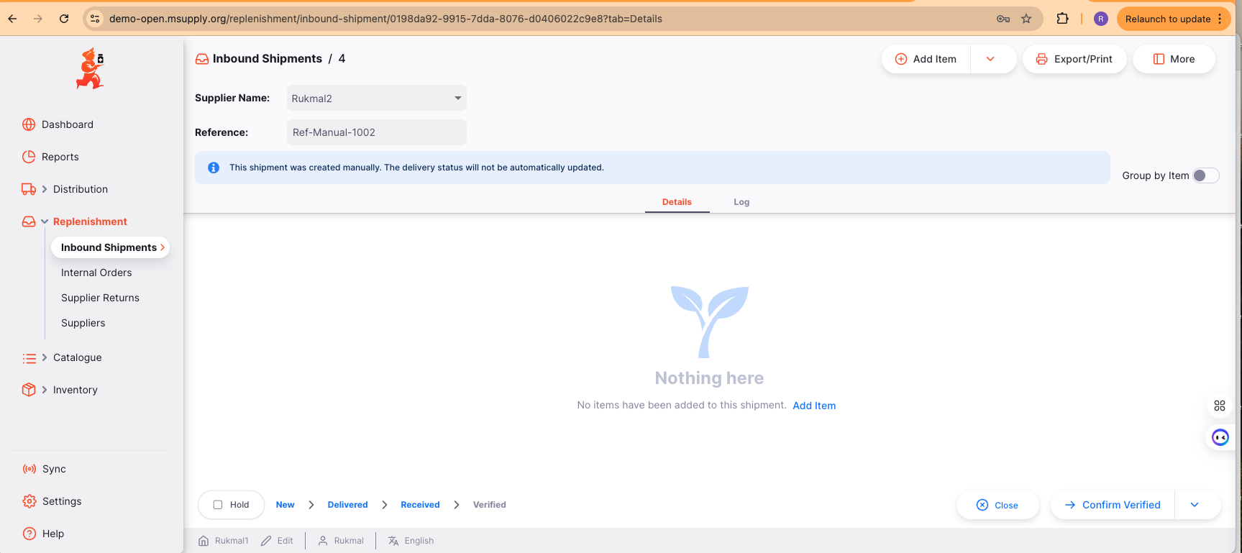

**Notes**

1. Login to the system and selected the Rukmal2 store
2. Click on creating new Replenishment button and selected supplier
3. Selected the Store “ Rukmal1”.
4. Created a new inbound order to the “Rukmal” supplier.
5. Created an new inbound order for “Amoxicillin 250mg tabs” for Supplier Rukmal
6. Created an new inbound order for “AR33197 ABACAVIR / LAMIVUDINE 60/30 MG CP” as a batch (5 batches), with different Expiry Dates for each batches.

Note: Should clarify what is the item variant field in this section.

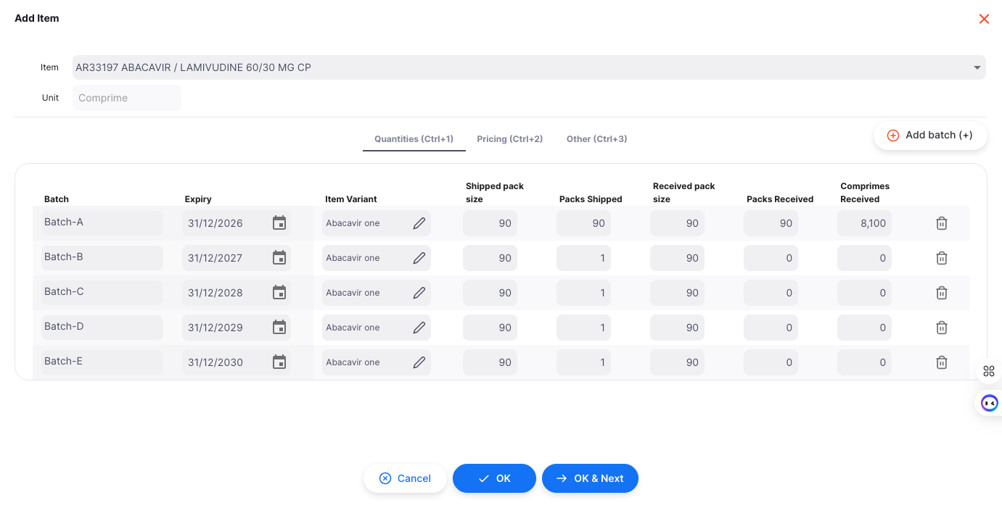

1. The User deleted the master list item from the inbound order.

**Note**: removing items took 30 seconds to remove 61 items from the list, I should check for performance with more items.

